Gap Analysis for JPMorgan Chase CEO (Commercial Electronic Office – Online Banking Portal for business customers)

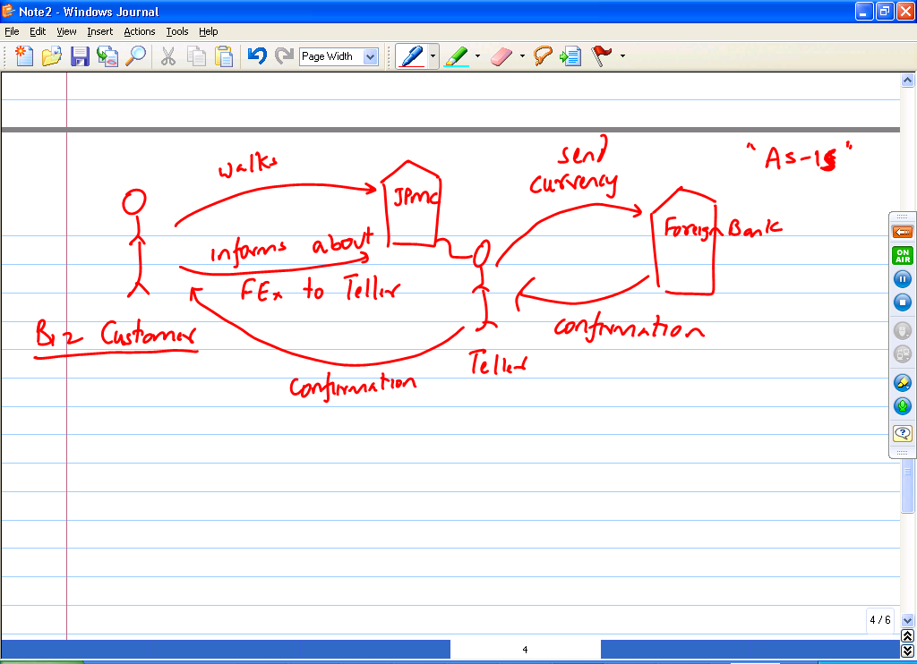

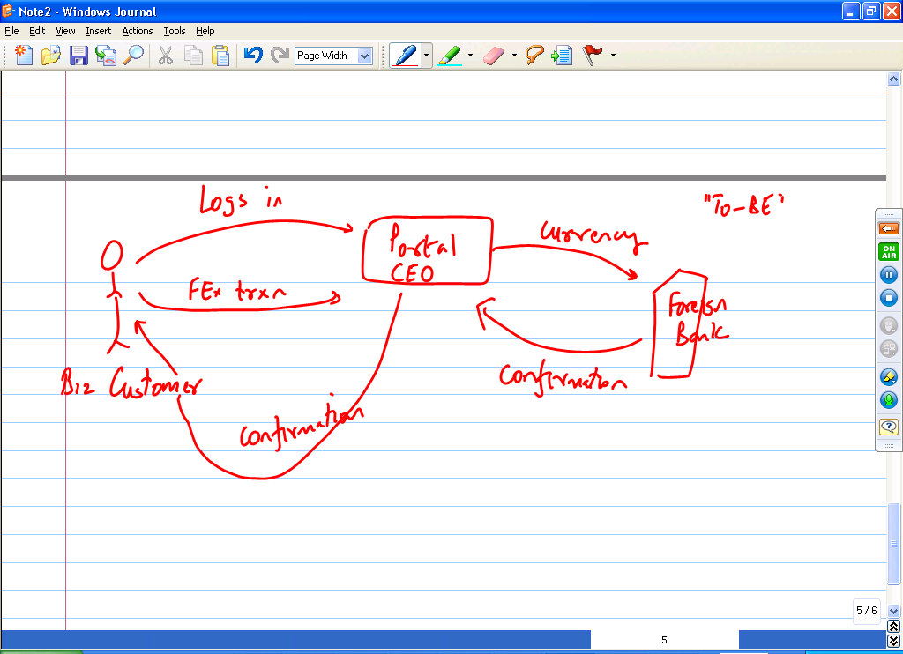

What gaps do we need to fill to implement this project?

- Update the existing portal (CEO) to integrate the Foreign Exchange functionality
- Train the Customer Support group for this new feature we are adding (Customer Support groups will get calls about this new feature so we better inform and train them about this new feature that we are making available on an existing portal)
- Set up deals with “Foreign Banks” to make sure they can handle electronic transactions from our portal (vs. manual directions given to Foreign Banks by our banking staff).
- Set up network communications with all the Foreign Exchanges of the world to have latest up to date information on exchange rates between currencies.

